Proposal For a New IT Software System

For client: FlyDreamAir

Contents

Justification of Project Selection 2

Business Case 3

Summary of the Case 3

Situation Analysis of Existing Business 4

Costs Benefits Analysis 6

Feasibility Study 8

SWOT analysis 10

Project Charter 11

Project Scope Management 13

Work Breakdown Structure (WBS) and Project Schedule 15

WBS Dictionary 15

Risk Management 15

Risk Identification 15

Risk Assessment 15

Risk Mitigation 15

Effort/Cost Estimation 15

Evidence of Effective use of Version System Control 15

Project Closing and Lesson Learnt 15

Meeting Records 15

# Justification of Project Selection

Macrosoft was hired by FlyDreamAir to investigate options to upgrade existing IT infrastructure. Macrosoft has analysed the three projects proposed by FlyDreamAir and recommends Project 3, the Airport Lounge Management System. The decision was based on the cost and benefits, risks, alignment with business objectives, stakeholder satisfaction, user acceptance, and other factors. This analysis indicated that Project 3 offers the most value and is the most feasible to implement within budget and time constraints. The Airport Lounge Management System will allow the airline to better manage its lounges worldwide, streamline customer membership and bookings, and improve the overall customer experience. To evaluate this, a weighted score model was conducted.

Weighted Score Model

|  |  |  |  |  |
| --- | --- | --- | --- | --- |
| **Criteria** | **Weight** | **Flight Management System** | **Loyalty Program Management System** | **Airport Lounge Management System** |
| Support key Business Objectives | 20% | 90 | 60 | 90 |
| Provides Positive NPV | 10% | 40 | 50 | 70 |
| Stakeholder Satisfaction | 5% | 80 | 70 | 60 |
| Has Low Risk in achieving Cost, Time and Scope Goals | 15% | 30 | 50 | 60 |
| Cost and Benefits | 15% | 70 | 40 | 50 |
| User Acceptance | 10% | 20 | 30 | 80 |
| Levels of Risk and Contraints | 25% | 80 | 70 | 80 |
| **Weighted Project Scores** | 100% | 66 | 59.5 | 78.5 |

The weighted score model above assesses three IT projects based on several criteria and assigns a weight to each criterion to determine the most optimal one. Based on the scores given, the Airport Lounge Management System emerges as the most optimal one to pursue as it has the highest weighted score of 78.5 out of 100. The Airport Lounge Management System. While the Flight Management System scored the highest in cost and benefits, it scored lower in other criteria, resulting in a lower weighted score of 66. The Loyalty Program Management System, on the other hand, scored well in stakeholder satisfaction but scored lower in other critical criteria, resulting in a lower weighted score of 59.5. Therefore, the results shown in the weighted score model, it is recommended that FlyDreamAir should pursue the Airport Lounge Management System as it aligns better with the organization's objectives and has the highest likelihood of success.

# Business Case

## Summary of the Case

FlyDreamAir is a rapidly growing company that provides its customers with both international and domestic flights. The company has identified a need to upgrade their lounge booking system to optimise productivity and elevate customer satisfaction. The purpose of this business case is to provide details of the situation analysis of the existing current business system, analysis of the costs vs benefits and a feasibility study which will determine whether the project is viable and if it should continue.

The situation analysis of the existing business highlights crucial details which outline prominent issues of the current system and how they are affecting customer satisfaction, that ultimately leads to a loss in revenue. It also provides a brief overview of what the company offers and where their lounges are stationed across the world. The issues with the existing system are poor customer service, poor membership management with uneven registration prices, long waiting times, double bookings, and cancellation due to overbooking. These issues are caused by the design of the user interface in 1999 and the lack of upgrades to make the system compatible with latest technologies. From the analysis of the existing business, it can ascertain that a new IT system needs to be implemented to improve FlyDreamAir’s customer satisfaction.

The analysis of cost vs benefits identifies the main objectives of the new IT system and how they will improve FlyDreamAir’s company. The cost of hardware, software, staff training, installation and ongoing maintenance have been evaluated. The benefits, both tangible and intangible, have been calculated. Tangible benefits include increased efficiency among both staff and customers, improved customer satisfaction, reduced cost and increased revenue. Intangible benefits include developing future customers in Gen Y and Millennials, to ensure the Lounge booking service is not seen as a liability and a negative part of the flying experience, surpassing competitors in the Lounge experience, achieve quality closer to premium airline services by matching its overall prospects, and finally improved customer satisfaction. To quantify the costs vs benefits of the new IT system, a Net Present Value (NPV) table was conduct as well as a Return On Investment (ROI) and both presented a strong case.

The feasibility study conducted analyses the new IT systems in a high level to determine whether it’s feasible to continue forward on implementing the project. The four main areas in which the feasibility study focuses on are technical, financial, operational and legal feasibility. It also performs a Strengths, Weaknesses, Opportunities and Threats (SWOT) analysis of FlyDreamAir’s company and through it, developed an understanding of FlyDreamAir’s lounge booking systems strengths and opportunities in the face of known weaknesses and threats (specifically poor user feedback). Ultimately, the study justifies the projects feasibility and clarifies that the project should be implemented.

Due to FlyDreamAirs rapidly expanding company and customer demands, it’s evident that the company needs a new IT system which will provide its customers and staff with an optimal system to increase productivity and revenue. The business case clearly states that the project should move forward and be implemented as soon as possible. This is apparent in the situation analysis of existing business, analysis of cost vs benefits and the feasibility study.

## Situation Analysis of Existing Business

FlyDreamAir is a well-known mid-priced airline that operates a substantial number of aircrafts, providing both international and domestic flights. The airline has an extensive customer base and network of travel agencies globally. The airline provides lounges facilities for its customer which allows them to relax, socialise and enjoy various amenities before and after their flight.

FlyDreamAir, a leading airline in Australia, currently operates 15 domestic lounges across the country and 12 lounges at major international airports (see Table 1). However, the airline's existing system for managing the lounges is plagued with inefficiencies and ineffectiveness. The system's poor customer service, long waiting times, inadequate occupancy management leading to double bookings that have resulted in numerous customer complaints. In the 2021 Airliner World annual report on airline performance, FlyDreamAir's lounge booking website was ranked 17th in the world, with only a 2-star performance. The feedback obtained from customers indicates that the current user interface has poor usability, inefficient design, inconsistent visual design, poor accessibility, lack of customer feedback, and slow performance. This lackluster user interface has caused frustration and confusion among customers, leading them to seek alternative airport lounge services. Consequently, this has caused a decrease in revenue and a negative perception of the FlyDreamAir’s company.

The FlyDreamAir lounge current system, which was implemented by Info Tech, a small company with limited experience in the field in 1999, was originally designed to handle 4000 customers per day for only 14 lounges. However, as FlyDreamAir expanded over the years and more customers took advantage of this service, numerous problems arose, particularly related to the obsolete software, which was based on Pascal and written in a Windows 2000 interface. Before the pandemic, the system was handling an average of 25000 customers per day for 37 lounges. The system has numerous interfacing issues with modern web browsers like Microsoft Edge and Google, and although the app can be downloaded from Google Play and the Apple App Store, its version is comparatively slow.

FlyDreamAir’s lounge booking system has been rated as a significant drawback for the airline's customers, as it has been rated only 2 stars in the 2021 Airliner World annual report on airline performance. This poor rating is in stark contrast to the top 10 airlines, which all have lounge booking systems rated at 4 or 5 stars. Despite FlyDreamAir operating at a lower price point than its main competitors, such as Qantas, BA, American, and Lufthansa, their lounge booking systems all scored higher in customer satisfaction. In fact, even in the Australian market, FlyDreamAir falls short compared to its main rivals, VirginBlue and Jetstar, both of which have 3-star rated lounge booking services, while Qantas enjoys a 5-star rating.

This substandard rating of FlyDreamAir’s lounge booking system has a direct impact on customer satisfaction, as it is a significant factor when customers choose which airline to fly with. Therefore, addressing this issue is critical for the airline's success. While the booking system's poor performance does not reflect on the quality of the features inside the lounges, such as food, furnishings, and services, the negative perception of the booking system may still affect the airline's overall revenue and market perception.

Macrosoft intends to modernise its business processes and operations by implementing a new system that will enhance productivity and provide a better experience for customers. The need for a new IT system to manage the airline's lounges across the world is therefore imperative to improve customer satisfaction, boost revenue, and enhance the company's reputation in the aviation industry.Top of Form

Bottom of Form

Table 1 – Current FlyDreamAir lounge locations

|  |  |  |  |
| --- | --- | --- | --- |
| **Domestic** | **Domestic** | **International** | **International** |
| Sydney | Canberra | JFK, New York USA | Tokyo, Japan |
| Melbounre | Hobart | CDG Paris, France | Heathrow, London, UK |
| Brisbane | Darwin | Rome, Italy | Auckland, NZ |
| Adelaide | Cairns | Beijing, China | Seoul, Korea |
| Perth | Townsville | LAX, Los Angeles, CA USA | Mumbai, India |
| GoldCoast | Launceston | Orlando, FL USA | Dubai UAE |
| Newcastle | Alice Springs |  |  |
| Port Headland |  |  |  |

## Costs Benefits Analysis (CBA)

This part of the project analysis is done in order to find any alternative that might be required to cut down unnecessary actions that might come up in the way to successful completion of the project .

The main objectives for the new IT system are:

* Improving customer satisfaction
* Reducing waiting times
* Increasing staff productivity and efficiency
* Increasing revenue
* Premium Quality experience in terms of effectiveness
* Improve the user interface

Before we go further we would like to introduce our stakeholders the different ways we can see the costs and benefits involved in a projects at least in the micro level .

This categorization of the costs that might be considered is because costs is not always that is reflected in terms of dollar rather there are various kins of recourses that is compromised and paid in terms to achieve the objectivity of our project

Following are instances for possible costs that coule be accounted :

**Direct Costs** associated with our projects include mostly the payment made for materials and the labor used for the creation .

This alone for our projects is $120600 and $127424 respectively .

Indirect Costs

The benefits that the new booking system will provide:

|  |  |
| --- | --- |
| **Tangible** | **Intangible** |
| Increased efficiency among both staff and customs (reduced staff time supporting users with the old system and its various issues) | Develop future customers in Gen Y and Millennials by using social media influencers Tik Tok, Instagram, Snapchat to persuade them to promote the company |
| Reduced operating costs (expensive to maintain old software systems incompatible with new hardware). | To ensure the Lounge booking service is NOT seen as a liability and a negative part of the flying experience |
| cxxxxx | FlyDreamAir must at least match its closest competitors in the Lounge experience and get as close as possible to the premium airline services. |
| Increased revenue (through additional purchasing options on the lounge booking system) | Improved customer satisfaction |
|  |  |

Quantifying the cost and benefits of the new IT system:

NPV -

ROI – As described in the Gantt Chart the cost for the software upgrade for the FlyDreamAir frequent flyer program is $10M. The project will take 2 years. (Change when worked out). The aim of this project is to ensure a ROI of atleast 10% in terms of immediate tangeible benefits. Almost as important is the ongoing intangible benefits of having younger customers (eg back packers) having a positive experience and thus being more likely to utilise FlyDreamAir in the coming years and decades.

Return on Investment – Assuming a discount rate of 7% - Lounge booking system.

|  |  |  |  |  |  |
| --- | --- | --- | --- | --- | --- |
| (k$) | Year 0 | Year 1 | Year 2 | Year 3 | Total (k$) |
| Costs | 4000 | 6000 |  |  |  |
| Discount Factor | 1 | .93 | .86 | .79 |  |
| Disc. Costs | 4,000 | 5,580 |  |  | 9580 |
|  |  |  |  |  |  |
| Benefits | 0 | 0 | 5000 | 7000 |  |
| Discount Factor | 1 | .93 | .86 | .79 |  |
| Disc. Benefits | 0 | 0 | 4,300 | 5,530 | 9830 |
|  |  |  |  |  |  |
| Disc. Benefits - Costs | (4,000) | (9,580) | (5,280) | 250 | 250 |
| Cumulative Benefits-Costs | (4,000) | (9,580) | (4,300) | 250 |  |
|  |  |  |  |  |  |
| ROI |  |  |  |  |  |
| Payback time |  |  |  |  |  |

Recommendation:

Based on the above analysis of the cost and benefits that the new system will deliver, Macrosoft’s recommendation is to proceed with the new Lounge booking IT system. Macrosoft strongly believes that the new system will greatly benefit FlyDreamAir’s company with both increased customer satisfaction and revenue.

## Feasibility Study

The feasibility study aims to evaluate the viability of implementing the proposed IT system and its potential benefits for FlyDreamAir. It will examine the technical, financial, operational, and legal aspects of the project, as well as any potential risks and challenges that may arise during the implementation process. By providing a comprehensive analysis of the project's feasibility, this study will assist FlyDreamAir in making an informed decision on whether to proceed with the implementation of the new IT system.

|  |  |
| --- | --- |
| **Technical Feasibility** | |
| Factors | Description |
| Compatibility | The new system is compatible with the existing FlyDreamAir website and the system technology and infrastructure such as hardware, software and network. |
| Security | A strong security system will be implemented to protect customer data and prevent cyber-attacks. The system meet the International Airline Travel Association (IATA) standard for Distribution with Offers and Orders (NDC). |
| Scalability | The new system will be able to handle future growth and expansion of FlyDreamAir’s company for a period of atleast 10 years. |
| User Interface | The new website is easy to navigate and requires minimal training. The interface is similar to new popular airlines systems apps such as Qantas and BA. |
| Reliability | Downtime of the new system was considered to avoid any disruptions in the booking process. Up time is expected to be greater than 99.99% (or less than 10 hours down time per year). |
| Integration | The new system can easily be integrated with common third-party systems. |
| Mobile Optimisation | The system is optimised for hand-held devices to accommodate for customers that prefer mobile usage. The system will easily operate on IOS and Android. |

|  |  |
| --- | --- |
| **Financial Feasibility** | |
| Factors | Description |
| Budget | A budget plan was created and includes estimated costs and expenses relative to developing the new system. The budget is X$M. |
| Funding | The new system will be funded internally from existing cash surplus on business loans. |
| Revenue Projections | Increased customer satisfaction and ongoing usage are two factors that were considered to develop the revenue projections of the new system. The return on investment is 3 years, assuming the build time of 24 months. There will be ongoing intangible benefits for a number of years. |
| Financial Risks | The cost overruns and unexpected expenses were evaluated, and a plan was developed to mitigate any financial risks. There project will have 10 milestone review stages at which time progress will be analysed against the plan. |
| Cash Flow Analysis | A cash flow analysis was conducted to determine whether the company have sufficient cash to support the project. The spend profile (as shown in table 3) is $5M year 1 and $5M year 2. After year 2 there is no ongoing project cost. Ongoing maintenance of the system will be 25% cheaper than the existing lounge booking system and will be covered in operational budgets. |

|  |  |
| --- | --- |
| **Operational Feasibility** | |
| Factors | Description |
| Integration with Existing Systems | The new system is compatible with the existing systems of FlyDreamAir, for example, it aligns with its customer membership, pay-per-use, bookings cancellations, occupancy management, and search for lounges. |
| User Acceptance | The new system is easy and appropriate to use across all staff, and adequate training will be provided for a smooth roll over to the new system. A training module is included in the project scope. A prototype will be beta tested by a select group of FlyDreamAir lounge staff. The feedback will be tabulated and all solutions will be incorporated into the final product. |
| Security | The new system has highly secure protocols that are able to protect customers sensitive information from cyber threats and complies with ICAO Annex 17 – Aviation Security 12th edition 2022. |
| Maintenance and Support | There are protocols in place to support and maintained the new system in case of the low likelihood any issues become present – it can be addressed. |
| Cost-Effectiveness | The new system is cost-effective in both implementation and maintenance costs which will provide a high return on investment for the company. |

|  |  |
| --- | --- |
| **Legal Feasibility** | |
| Factors | Description |
| Data Privacy and Protection | The new system will comply with the data protection and privacy laws of all countries that FlyDreamAir operates in. |
| Compliance with Aviation Regulation | The new system complies with all IATA (International) and CASA (Australia) aviation regulations such as managing passenger data, baggage handling, and cargo management. |
| Intellectual Property Rights | The new system does not conflict with any third-party intellectual property rights such as software, tools, or technologies. |
| Employment Laws | The new system adheres to necessary employment laws and procedures in terms of adequate training and protocols to maintain the safety of employees. |

## SWOT analysis

A Strengths, Weaknesses, Opportunities and Threats (SWOT) analysis was undertaken on the current situations regarding lounge bookings for FlyDreamAir.

|  |  |
| --- | --- |
| **Strengths** | **Weakness** |
| * The quality of the existing lounges is rated good or above for all 15 domestic lounges. * The quality of the 12 international lounges is also rated good, however a little below the level of many of the larger carriers. * The locations of the lounges is convenient in nearly every case. * Customers are familiar with the current booking system * FlyDreamAir has a strong reputation in the aviation industry for its reliability and on-time performance. * The existing lounges offer a variety of amenities and facilities, such as comfortable seating areas, Wi-Fi access, and refreshments. * The airline's brand image is associated with luxury and premium travel experiences, enhancing the appeal of its lounges. | * The interface is now archaic, resembling old Windows 2000 and XP7 interfaces. * It is a difficult system for staff, particularly new staff to use. * The number of people accessing the system can overload it, and makes for a very long refresh time. * It can cause double bookings at periods of high use. * The system has been updated in bits and pieces over the last 24 years, and the patches are being harder to accurately track. The developers have all long since moved on. |
| **Opportunities** | **Threats** |
| * The implementation of a state-of-the-art IT system in 2023 presents an opportunity for FlyDreamAir to gain a competitive advantage in the market. * FlyDreamAir's competitors have not yet announced plans to upgrade their lounge management systems, giving the airline a first-mover advantage. * The new system's compatibility with the latest software and technology opens up opportunities for seamless integration with other digital platforms and services. * Integrating the new system with FlyDreamAir's rewards program can enhance the overall user experience, providing customers with added benefits and incentives for utilizing the lounges. * The new system can support future growth and expansion plans, accommodating an increasing number of lounges and customers as FlyDreamAir continues to expand its network. | * The premium airline competitors have recently released advanced new features, like custom games for kids while in the lounge and in flight. * Fewer and fewer people book on a computer, they use phones and tablets instead. * Airline mergers mean smaller airlines, taken over by larger ones, have access to the larger airliners systems, such as lounge bookings. * The larger budgets of the main airlines mean they can produce additional upgrades more quickly, making our system seem even older. |

Based on the analysis presented above, it can be concluded that the implementation of the IT system is a feasible project. The analysis indicates that the new system would provide great benefits to FlyDreamAir. Benefits include increased revenue, improved customer relationships, and enhanced productivity. Therefore, it is recommended that the new system is implemented to enhance lounge booking services.

# Project Charter

|  |  |  |  |
| --- | --- | --- | --- |
| **Project Title:** Airport Lounge Management System | | | |
| **Date of Authorisation:** 26th May (Fri), 2023 | | | |
| **Project Start Date:** 29th May (Mon),2023 | | **Project finish Date:** 17th of October | |
| **Key Schedule Milestones:**   * Requirements gathering completed by June 16th * **Analysis of business and customer response completed by June 28th** * **Discussion and Planning completed by July 7th** * **Designing user interface, configuring hardware and** * Roll out new IT system by November 1 | | | |
| **Budget Information:** | | | |
| **Project Manager:** Bradley Harris, Phone: 0437435885, [brh980@uowmail.edu.au](mailto:brh980@uowmail.edu.au) | | | |
| **Project Objectives:** The objectives of the new IT system are to enhance customer satisfaction by providing a more efficient and streamlined booking process. It also aims to reduce waiting times by improving the booking system and eliminate redundant fields that require users and staff to repeat information already provided. Therefore, it is expected to boost revenue by increasing sales and improving the overall booking experience. The system also is intended to increase staff productivity and efficiency by automating some manual processes and reducing workload. Lastly, the project aims to improve the user interface to make it more intuitive and user-friendly. | | | |
| **Main Project Success Criteria:** The system must meet all specification on schedule and within budget. Feedback from customers and stakeholders will be an essential assets to the project. The system has to be scalable and adaptable to future changes and growth. It also must meet all legal and regulatory requirements of the aviation industry. The system must be reliable and secure, with appropriate measures in place to protect sensitive data.  The system also must be user-friendly and intuitive, with clear and concise instructions for both customers and staff. As well as, it has to be tested thoroughly to ensure that it is functioning as intended and meets all performance and quality standards. | | | |
| **Approach:**   * Develop a work breakdown structure, scope statement and Gantt chart detailing the work required to complete the new IT statement. * Integrate and purchase required hardware for the new IT system. * Weekly meetings will be held with the core project team and relevant stakeholder * Continuously run software tests to determine if the software is compatible and reliable. | | | |
| **Roles And Responsibilities** | | | |
| **Name** | **Role** | **Position** | **Contact Information** |
| Bradley Harris | Project Manager | Manager | brh980@uowmail.edu.au |
| Mitchel Olsen | Team Member | System Analyst | mo370@uowmail.edu.au |
| Rhys Matthews | Team Member | Programmer | rm514@uowmail.edu.au |
| Duc Huy Tran | Team Member | Documentation Manager | dht185@uowmail.edu.au |
| Soham Verma | Team Member | System Analyst and Programmer | Sv948@uowmail.edu.au |
| Sourav Laha | Team Member | System Analyst | sl523@uowmail.edu.au |
| **Sign-off:** B.H., M.O., R.M., D.H.T., S.V., S.L. | | | |

# Project Scope Management

|  |  |
| --- | --- |
| **Project Title:** Airport Lounge Management System | |
| **Date:** 29th May (Mon), 2023 | **Prepared by:** Bradley Harris, Phone: 0437435885, [brh980@uowmail.edu.au](mailto:brh980@uowmail.edu.au) |
| **Project Summary and Justification:**  FlyDreamAir has noticed a need for a new IT system to manage its airport lounges. The existing system was implementing in 1999 and was only intended to held 4000 customer a day. Due to the increase of customers over the years, the system often crashes and would be down for a day, preventing people from interacting with it. The system was also written in pascel which is not compatible with many current operating systems. The new system will be user friendly for customers and staff, allowing productivity and customer satisfaction to increase. It will also significantly reduce the workload of staff by allowing customers to book airport lounges without the need for extensive assistance from employees. The budget for the project is $248,024. After the project is completed, an additional $xxxeach year is required for operational maintenance. The project must have a payback period of no more than one year. | |
| **Product Characteristics and Requirement:**   1. Hardware and system: The new IT system will be integrated with the existing hardware. The software should be compatible with modern day technology, easily integrate with third-party applications. This will allow easy visibility among airport services. The database with low-latency provision would enable efficient data flow to make the system more responsive. 2. User Interface: The new IT system will implement an interface which is compatible with modern operating system and will allow customer access booking system. A website will be developed using Hypertext Markup Language (HTML). The design of the website will be hieratical so that users are able to navigate it easily. | |
| **Summary of Project Deliverables**  **Project management-related deliverables:**  Business case, project charter, project scope statement, WBS, WBS dictionary and project schedule, risk management, effort/cost estimation, demonstration of project execution, effective use of version control system, project closing, and lesson learnt, meeting records, user interface prototypes and functionality implementation.  **Product-related deliverables:**   1. Website: Design on the website is user-friendly, and people will be able to access it via any browser as well as being stable and responsive. This will allow more customers to book simultaneously in real-time. It will have links to enable customers to register for membership, check for availability of lounges, their bookings and cancellation, pay-per-use prices. Additionally, the website will consist of accessibility features such as Text-to-speech, and magnification. Customers will be delivered mobile and email notifications for registrations, memberships, availabilities and cancellations. 2. Staff Portal: The new system will provide a staff portal so staff can manage and organise customer details and credit information. The portal can allow staff to log in their hours which can track their availability. It also provides facilitated feedback to improve the website. 3. Database: The database system will allow staff to store information about bookings or cancellations for lounges, occupancy management, customer membership. | |
| **Project Success Criteria:**  Our goal is to complete this project within ???weeks for no more than $????. The main goal is to provide a new IT system which will optimise airport lounge management system. To achieve this the system must meet all requirement with the given time and budget. Customer satisfaction and Staff productivity will be prioritized with the help of feedback from customers, staff members, and stakeholders. The system must be flexible to accommodate various booking options and facilitate more customers and server load while being stable and comprise of security features. It also must meet all legal and regulatory requirements of the aviation industry. It should also be accessible, multi-lingual, with clear and concise instructions for users. As well as it must be tested thoroughly to ensure that it is functioning as intended and meets all performance and quality standards. | |

# Work Breakdown Structure (WBS) and Project Schedule

# WBS Dictionary

|  |  |  |  |
| --- | --- | --- | --- |
| Task No. | Item | Description | Owner |
| 1 | **Requirements Gathering** | To obtain the requirements for the project and useful data to assist with the development of the project. |  |
| 2 | Construct questionnaires & interview questions | Constructing questions to ask customers of FlyDreamAir to later be published online. Creating questions to ask the staff of FlyDreamAir for interviews to be carried out. These questions will ask about the work processes, work environment, and management related tasks. |  |
| 3 | Gather relevant business documentation and processes | Gather and copy the relevant documentation for the business that includes the processes taken for bookings, payments, and scheduling as well as existing infrastructure used to execute these tasks. |  |
| 4 | Conduct interviews with staff | Interviewing the staff members and managers to get an insight of the day-to-day operations in the lounges. |  |
| 5 | Publish survey for customers | Hosting a questionnaire on a website sent out to the customers of FlyDreamAir for insight on the customer’s opinions, preferences, and issues with the lounges. |  |
| 6 | Sort and categorise data gathered | Taking the data that has been gathered and sorting it into useful information to analyse later. |  |
| 7 | *Requirements phase completed* | All requirements to move ahead with the project have been gathered and are ready for the analysis phase. |  |
| 8 | **Analysis Phase** | The process of analysing the data that has been gathered to learn to output useful information to assist with the development of the new booking system. |  |
| 9 | Analyse gathered business data | Analyse the documentation and business data from FlyDreamAir to find key components and gather ideas for the new booking system. |  |
| 10 | Analyse customer responses | Gather the responses from the customer surveys/questionnaires for analysis. Identify customer likes and dislikes, and desired preferences. |  |
| 11 | Identify key system requirements | Through analysing the data gathered, identify the key components that are required for the business to operate with the proposed booking system. |  |
| 12 | *Analysis Phase Completed* | Data gathered has been analysed and put into useful information to use in the design phases. |  |
| 13 | **Discussion & planning** | Discussion and planning to come up with ideas and to identify requirements for the design. |  |
| 14 | Internal discussion workshops | Discussion with members of the Macrosoft team to brainstorm ideas and lay out plans for the booking system design. |  |
| 15 | Discussion workshops with staff and stakeholders | Hosting discussion and idea workshops with staff and other stakeholders of FlyDreamAir. Closely collaborating with members of the business ensures the new booking system is created with their ideas in mind. |  |
| 16 | Create use cases | Taking the information gathered from the discussion workshops, use cases are created to further understand how the system should handle different inputs. |  |
| 17 | Create activity diagrams & process flows | Using the use cases, create diagrams showing the processes from beginning to end with all components and classes involved. |  |
| 18 | *Discussion & planning completed* | All planning is completed for the design phase to use for its development. |  |
| 19 | **Design Phase** | Designing all the components of the booking system which includes the front and back end of the system. |  |
| 20 | Design database structure | Designing how the database will store all the bookings, customer data, lounge data, and other information the system will use. Data backups and failovers will be part of this design. | Rhys Matthews |
| 21 | Design hardware infrastructure | Using information from the database design team, hardware requirements are identified and a design is created for the back-end infrastructure to support the new system. | Bradley Harris |
| 22 | Create booking management portal | Creating a web portal for the staff to use for managing bookings and lounge status updates. The website supports different levels of staff logins and can only be accessed within FlyDreamAir’s domain. Staff can create, adjust, or remove bookings from this portal. |  |
| 23 | Create front end website | Creating the customer facing website where lounge information and booking options will be available. Website will support customer logins and save user data. | Soham Verma |
| 24 | Tie together system components | Making sure the different system components work together by design to be later tested in the testing phase. While the developers have already taken this into consideration with the design, some components may have been overlooked. |  |
| 25 | *Design phase completed* | The design of the system is completed and ready for testing before being deployed. |  |
| 26 | **Testing & adjusting** | Running dummy tests on the system with real world scenarios to test its functionality and stability. This process will identify any bugs or missing components that need to be corrected. |  |
| 27 | Create testing environment | Setting up a virtual testing environment for the system to run on. High performance servers will be leased for a short duration for these tests. |  |
| 28 | Simulate business processes | Simulating the business processes within the test environment which includes bookings, account creations, user information modifications, lounge status updates, and any other procedure the staff at FlyDreamAir will carry out. |  |
| 29 | Gather test results & data | Gather results from testing the system in the virtual environment. These results include performance of the hardware, efficiency of executing tasks, and the overall effectiveness of the system completing the business’ processes. |  |
| 30 | Make necessary adjustments to software | Based off of the results gathered, make adjustment to fix any identified issues in performance or stability. If needed, adding any features that were overlooked in the design phase. |  |
| 31 | *Testing & adjusting completed* | Testing and adjusting the project it is completed and the software is ready to be deployed in the real world. |  |
| 32 | **Implementation** | The process of installing the system for FlyDreamAir. |  |
| 33 | Deploy server hardware | Setting up the server hardware in FlyDreamAir’s network facilities and testing connectivity |  |

# Risk Management

FlyDreamAir’s lounge booking system is a substantial application for a global airline, resulting in a number of risks posing a threat to the development of the IT system.

Thorough analysis was needed to prepare and mitigate the risks and was achieved through different stages of risk identification, assessment, and mitigation.

## Risk Identification

Macrosoft has identified numerous risks associated with the development of FlyDream Air’s IT System. Methods utilised to determine realistic risks include assessing a previous risk register of a development undertaken by Macrosoft, brainstorming and interviewing individuals with similar project experience.

Valid risks to FlyDream Air’s IT system attained from assessing another similar risk register from a previous Macrosoft development, a café booking system.

|  |  |  |  |  |
| --- | --- | --- | --- | --- |
| **ID** | **Risk** | **Category** | **Severity 1-5** | **Mitigation** |
| **1** | The delivered product does not achieve project requirements. | Technical | 5 | Maintain agile approach, weekly meetings, clear milestones. |
| **2** | New system won’t integrate well with existing system. | Technical | 3 | Prepare a thorough implementation and maintenance plan. |
| **3** | Fluctuating project requirements from stakeholders. | Requirements | 2 | Maintain agile approach, weekly meetings, communicate feasibility of new requirements. |
| **4** | Team member absence delaying project. | Resources | 3 | Adaptive task assignments, weekly meetings, set and maintain team member expectations. |

The two other methods utilised to determine risks were brainstorming and interviewing. Brainstorming was a key method in identifying additional threats to the project’s development. Various people were involved in a group setting, including members of the development team and stakeholders. Additionally, interviewing experienced individuals based on their previous involvements in similar developments allowed for more specific risks to be identified.

The potential risks recognised from the different methods mentioned were then grouped into different categories and summarised as follows:

|  |  |  |
| --- | --- | --- |
| **Category** | **ID** | **Associated Risks** |
| Technical | A1    A2  A3 | * Delivered product’s function doesn’t achieve project requirements. * New system won’t integrate with existing system. * The project is too complex. |
| Requirements | B1  B2 | * Everchanging project requirements. * Unfeasible requirement changes. |
| People | C1  C2  C3  C4    C5 | * Team-member absences delaying project. * Low productivity. * Insufficient skills or training. * Unforeseen, non-work-related circumstances resulting in team absences. * Insufficient communication leading to confusion. |
| Resources | D1  D2  D3 | * Exceeding budget. * Project not completed within planned time. * Lack of resources due to supply issues. |

## Risk Assessment

|  |  |
| --- | --- |
| **Probability** | **Chance of happening** |
| High | Greater than 60% |
| Significant | 31-60% |
| Moderate | 15-30% |
| Low | Less than 15% |

|  |  |
| --- | --- |
| **Impact Severity** | **Percentage of budget required to overcome risk’s impact** |
| High | Greater than 25% |
| Significant | 16-25% |
| Moderate | 5-15% |
| Low | Up to 5% |

**Probability-Impact Matrix**

|  |  |  |  |  |  |
| --- | --- | --- | --- | --- | --- |
| **Impact** | **High** | A3 | B2  A1 | B1 |  |
| **Significant** | A2 | C2 |  |  |
| **Moderate** | C3 | C1  C4 | D1 | D2 |
| **Low** |  | D3 |  |  |
|  | **Low** | **Moderate** | **Significant** | **High** |
|  | **Probability** | | | | |
|  |  | | | | |

Macrosoft has determined that items B2, A1, B1 and D2 are the most prevalent risks to FlyDream Air’s lounge booking system. The items all have a combination of varying degrees of moderate to high impact severity and moderate to high probability. These prominent risks are summarised and contain aspects of volatile project requirements, unfeasible project requirements and the project not finishing in time. Macrosoft has prioritised these risks and decided to strengthen risk mitigation strategies in the areas relating to project requirements and time management.

## Risk Mitigation

Macrosoft has evaluated the risks mentioned in the identification step and has created mitigation strategies for them all. Additionally, a strong emphasis was placed on the creation of the strategies concerned with project requirements and time management, areas outlined from the risk assessment.

The following table is a complete list of the risks identified and their respective mitigation strategies:

|  |  |  |  |
| --- | --- | --- | --- |
| **Category** | **ID** | **Risk Description** | **Mitigation Strategies** |
| Technical | A1 | Delivered product’s function doesn’t achieve project requirements. | * Weekly meetings, assess development progress. * Clear goals. * Project state re-assessed at milestones. |
| Technical | A2 | New system won’t integrate with existing system. | * Ensure development compliments existing system. * Prepare thorough implementation plan. * Prepare maintenance plan. |
| Technical | A3 | The project is too complex. | * Limit project scope if necessary. * Hire additional project members with appropriate skillset. |
| Requirements | B1 | Everchanging project requirements. | * Efficiently communicate with stakeholder(s). * Weekly meetings to keep project team updated. |
| Requirements | B2 | Unfeasible requirement changes. | * Communicate prepared feasibility assessment towards stakeholder(s). |
| People | C1 | Team-member absences delaying project. | * Distribute workload evenly amongst remaining team-members. * Project lead informed of absences promptly. |
| People | C2 | Low productivity. | * Implement methods to promote involvement and team cohesion. * Communicate team expectations. |
| People | C3 | Insufficient skills or training. | * Provide training in any new technologies required for development. * Ensure project team has diverse set of skills. |
| People | C4 | Unforeseen, non-work-related circumstances resulting in team absences. | * Distribute workload evenly amongst remaining team-members. * Utilise project slack if necessary. * Propose overtime work. |
| People | C5 | Insufficient communication leading to confusion. | * Maintain weekly meetings. * Strengthen project member’s communication skills via training. |
| Resources | D1 | Exceeding budget. | * Maintain scope. * Follow resource management plan. * Minimise errors and wasted resources. |
| Resources | D2 | Project not completed within planned time. | * Conduct regular team meetings. * Adaptive scheduling. * Continually measure and assess ongoing progress. |
| Resources | D3 | Lack of resources due to supply issues. | * Ensure sufficient communication with suppliers to notify if any disruption. * Have alternate suppliers. |

# Effort/Cost Estimation

This part of the project involves calculating the cost based on the effort required to finish the project. There are substantial evidences as to why the effort/cost estimation is very crucial to the project. According to one of the reports of Harvard Business Review 2011 most projects are 27% cost overrun. Considering this data we have little chance to take the risk of getting overrun as we already witnessed this existing system of the FlyDreamAir lounges management system as been incapable of giving proper return of revenue over the years .

Cost here involves both tangible and intangible elements. We will analyse all the parts as to how our activities are pertinent and important to our project involving all aspects of cost(resources sacrificed to achieve the objective to be precise ).

But before discussing the intangible aspects of cost we will try estimating effort in terms of the very two conventional methods of calculating effort and cost being functions points and COCOMO .

***Function points Method :***

We will try estimating the effort based on the technical intricacies of our application for management of lounges for FlyDreamAir . This reflects the top down , algorithmic method of calculation the function point involved and to what degree it is affecting our ability to finish and achieve the scope of out project.

Determining Value Adjustment Factor:

|  |  |  |  |
| --- | --- | --- | --- |
| *General System Characteristics* | | *Brief Description* | *Degree of Influence*  *(0-5)* |
| 1 | Data Communications | Number of Communication Facilities involved | 3 |
| 2 | Distributed Data processing | How it is handled | 3 |
| 3 | Performance | Did user required throughput | 4 |
| 4 | Heavily used configuration | How heavily the current hardware system is used | 2 |
| 5 | Transaction rate | Frequency of transaction | 4 |
| 6 | On-Line Data Entry | Percentage of information put onine | 3 |
| 7 | End-User Efficiency | Was the app designed for end-user efficiency ? | 5 |
| 8 | Online Update | No of ILF’s updated | 3 |
| 9 | Complex Processing | Degree of entent mathematical and logical processing involved | 4 |
| 10 | Reusuability | Made to meet one or multiple user’s need | 5 |
| 11 | Installation ease | Difficulty of conversion and installation | 3 |
| 12 | Operational ease | Effectiveness and /or automated are start-up , back up and recovery | 5 |
| 13 | Multiple sites | Whether made for multiple sites and organisations | 5 |
| 14 | Facilate change | Can go change or modifications | 5 |
|  |  | Total | 54 |

Therefore Value Adjustment Factor (VAF) is given by :

*VAF = 0.65 + (0.01 * TDI)*

*= 0.65 + (0.01*54)*

*= 1.19*

Now we will Determine the unadjusted function points roughly

* The Account making procedure involves updating 2 Record Element Types(RET) and around 10-15 Data Element Types(DET)

i.e Customer Details and Payment Details

That is an internal logic files(ILF) of low complexity 7 points

* For the lounge selection part just 1 E0 of medium complexity
* Affects 2 to 3 File Type References(FTR) and 6 to 10 Data Element Types(DET)

5 points

Similarly Considering the other functionalities of the application

including the Occupancy , manage Booking , membership and catering depending upon the user enquires this can affect more than 3 FTR and more than 30 DET

Summing all the possible activities and their functionalities

-it comes up as an EI of high complexity that is 6 points for each ILF

An estimation has been made based on the number of files being affected is around 50 files

Therefore total Unadjusted Function Points = 6 * 50 + 5 + 7

= 300 + 12 = 312 points

Finally FP or adjusted function points = UFP * VAF

= 312 * 1.19 = 371.28 points

**Constructive Cost Model or COCOMO :**

This model was developed by Barry Boehm and has primality 2 versions . We will analyse our project bas on both of them namely the basic version and the COCOMO II ‘

*Basic COCOMO:*

*Our model of the project is meant to be classified as semi detached as it falls somewhere between the organic and embedded one .It is based on the definition of what organic and embedded kind of projects are . We are somewhere between a small group trying to accomplish something based on similar flexible requirements in an in-house environment and with also some parts having very tight constraints as the deployment is being made in the airports and in different countries we are subjected in the framework of various kind of laws and jurisdiction .This situation perfectly categorise our system amongst the semi- detached group of system*

*Hence we get our constants for the effort calculation from the table already defined for c and k and they being 3.0 and 1.12 respectively*

**effort = c x sizek**

Size here is measured in terms of term of thousands of lines of codes(KLOC), and the effort is measured in person months

Now for this system we are roughly around 20 thousand lines of code

Implies Effort = 3.0 x 201.12

= 85.96

Furthermore, we will delve into explaining our system based on the model of COCOMO but a through a more modern approach

*COCOMO II*

The model so far is the most flexible one in terms as to when and what stage of our project is being considered. For instance, COCOMO II can be applied to early stage that is way before the system is being designed or the post architecture one , the one that is applied once the system is implemented .

Considering we are at the early stage of our development we now will try dissecting our project for the estimation of effort using COCOMO II .

So this one works by

Calculating effort in terms of person months by the given formula

**pm = A(size)(sf) ×(em1) ×(em2) ×(em3)….**

Values of each element on the right hand side are as follows :

A = 2.94

Size = 20 KLOC

Sf = scale factor

And em1 , em2 … are effort multiplier depending upon the kind of project that is being dealt with

The calculation of scale factor :

**sf = B + 0.01 ×Σscale factor values**

*where B is a constant with value 0.91 (value found through normalization of various factors)*

*Calculating the relevant effort multiplier :*

Precedentedness

**PREC :** degree to which past projects can be taken into accounted

is high therefore the score is 2.48

Development Flexibility

**FLEX :** degree of flexibility while implementing the projectis nominal hence the score for this project is 3.04

Team Cohesion

**TEAM :** degree to which the team is dispersed or assembled together to be able to contribute in the project is nominal as well hence it scores 3.29 as well

Therefore **Σscale factor values = 2.48 + 3.04 + 3.29**

**= 8.81**

**so sf = 0.91 + 0.01 * 8.81**

**= 0.9981**

**0.91**



Hence the estimated effort is

pm = 2.94 * 200.91

= 44.9

Now that we have the estimated effort in person months , we now can use the possible effort multiplier to narrow down and have more precise look into the project

em1 = product reliability and complexity :RCPX is nominal = 1

em2 = reuse required :RUSE is very high = 1.07

Therefore the adjusted estimated effort = 44.9 * em1 * em2

= 44.9 * 1 * 1.07

= 48.04 person months

# Evidence of Effective use of Version System Control

# Project Closing and Lesson Learnt

# Meeting Records

User Interface Prototypes

**Initial prototype, displaying early direction.**

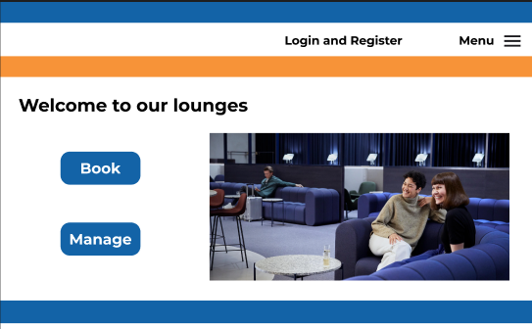

**User WebApp Homepage**

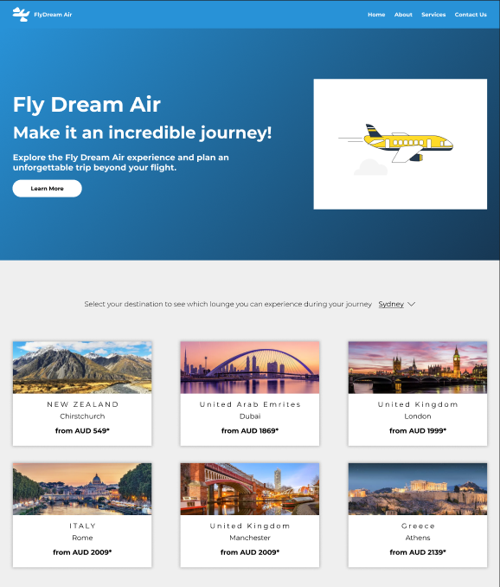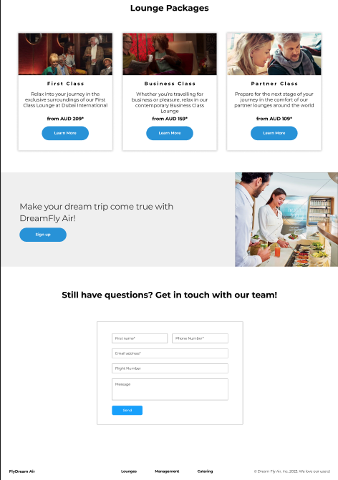

User Dashboard and Login

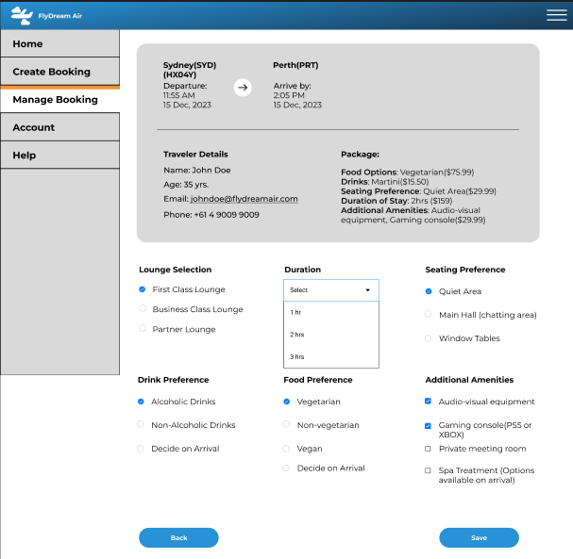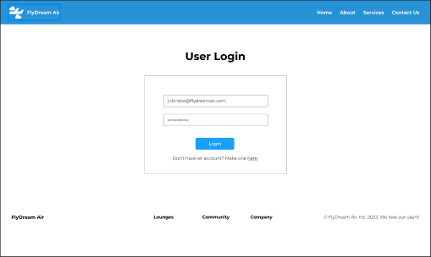

**User lounge preferences when booking**

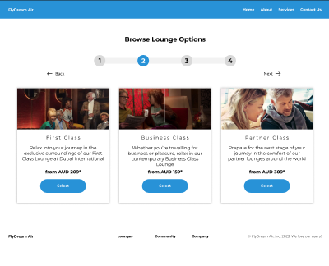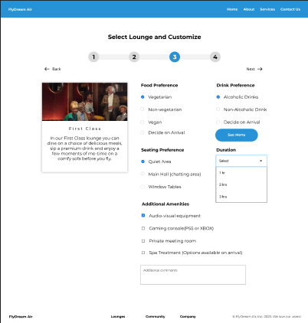

**Management Dashboard – Occupancy and Booking Creation**

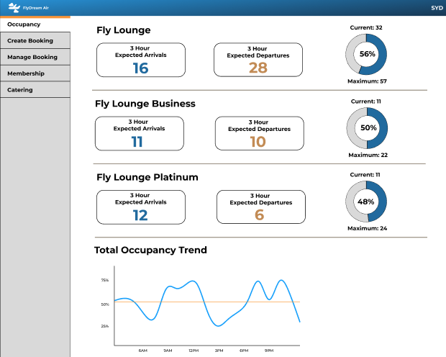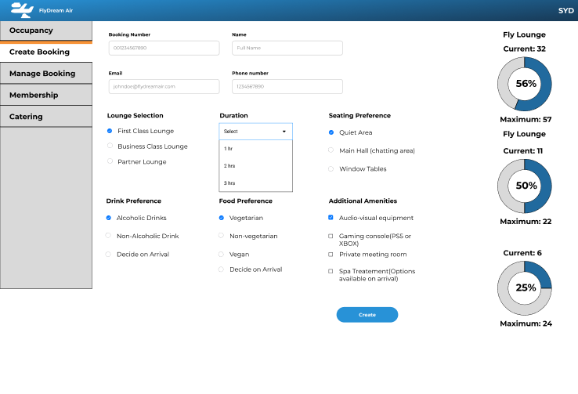

**Management Dashboard – Manage Bookings and Memberships**

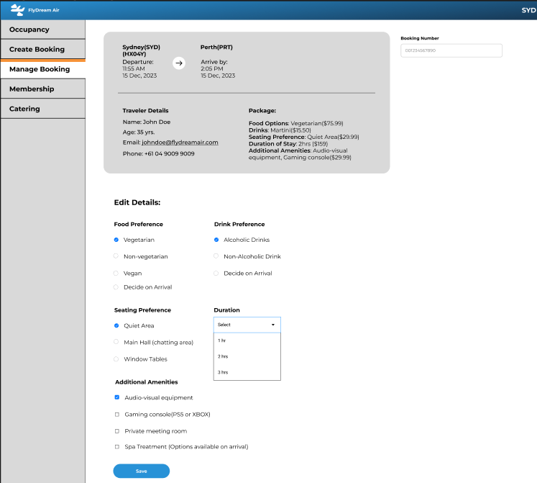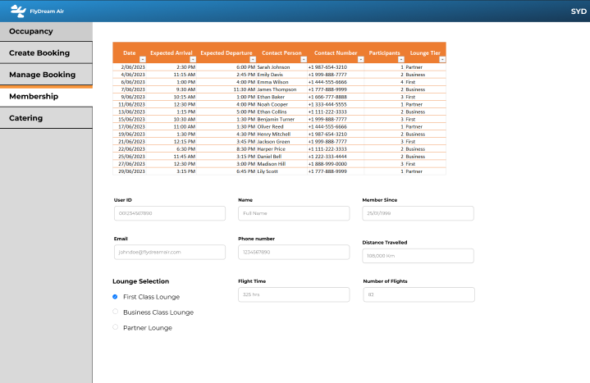

Management Dashboard - Catering

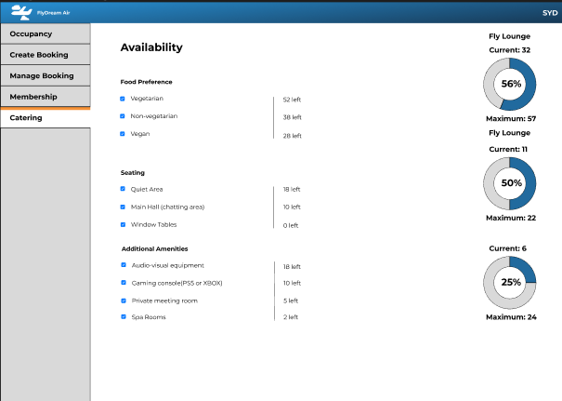

Functionality Implementation